07/03/22

Implement Laravel’s templating solution blade for PHP,

Implement Bootstrap, CSS and JavaScript libraries

Configure XAMPP to redirect to the correct pages

Consider using Livewire

08/03/22

Livewire didn’t workout. For this solution Blade will work.

Login system, signup, signout is all working

Can’t get the content part of the page to align as needed

Todo- tidy code, create appropriate layout and comments

11/03/2022

An issue with the Blade templates is proving difficult to use with a dynamic navigation bar.

Having an issue with Bootstrap’s grid system. Having consistent layouts that match the content is proving difficult.

16/03/22

Switched to using Flex Boxes, they work much better. This design doesn’t fit the design proposed in task 1. However using flex boxes, a future version of the solution could fit a closer match to the design proposed originally.

Navbar and scaling needs tweaking and fixing.

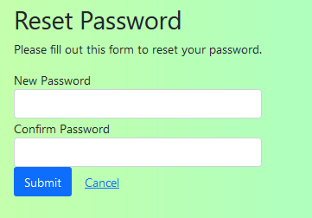

Users can now reset their password.

18/03/22

Getting the php to change the password in the right database isn’t working.

Code needs organising and commenting, to make sure that is understandable to someone who doesn’t understand code.

Used classes to make the navigation bar responsive. The navigation bar will now update and highlight which page the user is on.

Teachers and students no longer share a dashboard. Although there is no content on either right now, the pages have different boxes intended for different content.

Students and teachers now have separate login and signup pages.

4 boxes take up 25% of the space each. This is simply due to simplicity and having it easy to maintain however in the future I plan on making it more interesting design

In the next version, login and signup pages will be merged to work as one. This will make it easier to navigate.

21/03/22

Teachers can now see students, they are able to edit their details (username, however I plan on adding email, firstname and lastname.) Teachers can’t change their ID, they can’t change or view their password.

Teachers will be able to delete students aswell.

Working on adding more student details to the database

22/03/22

Managed to get relationships working between tables in the database.

SELECT students.username AS Student_name, courses.name AS Course, teachers.username AS Teacher_name

FROM classes

INNER JOIN students ON classes.fk_student=students.id

INNER JOIN courses ON classes.fk_course=courses.id

INNER JOIN teachers ON classes.fk_teacher=teachers.id

WHERE courses.id=2

The SQL statement doesn’t work quite as intended. It provides data only for certain students.

23/03/22

I removed the option for any teacher to edit any student’s data as it posed a threat to security. Teachers can now only see their students. Students, teachers, courses, and classes now all have separate tables. These tables share relationships among them. Each table has a primary key which allows complex SQL searches.

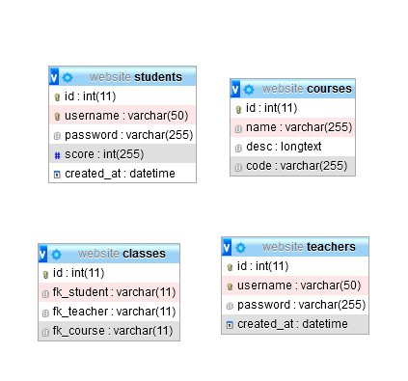

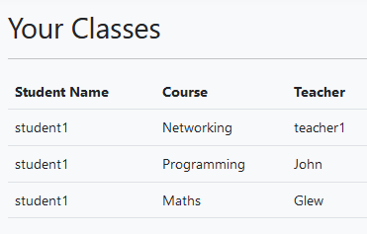

Students can see their classes, which course and the teacher who runs the class.

Teachers can see their students and which course they’re on.

28/03/22

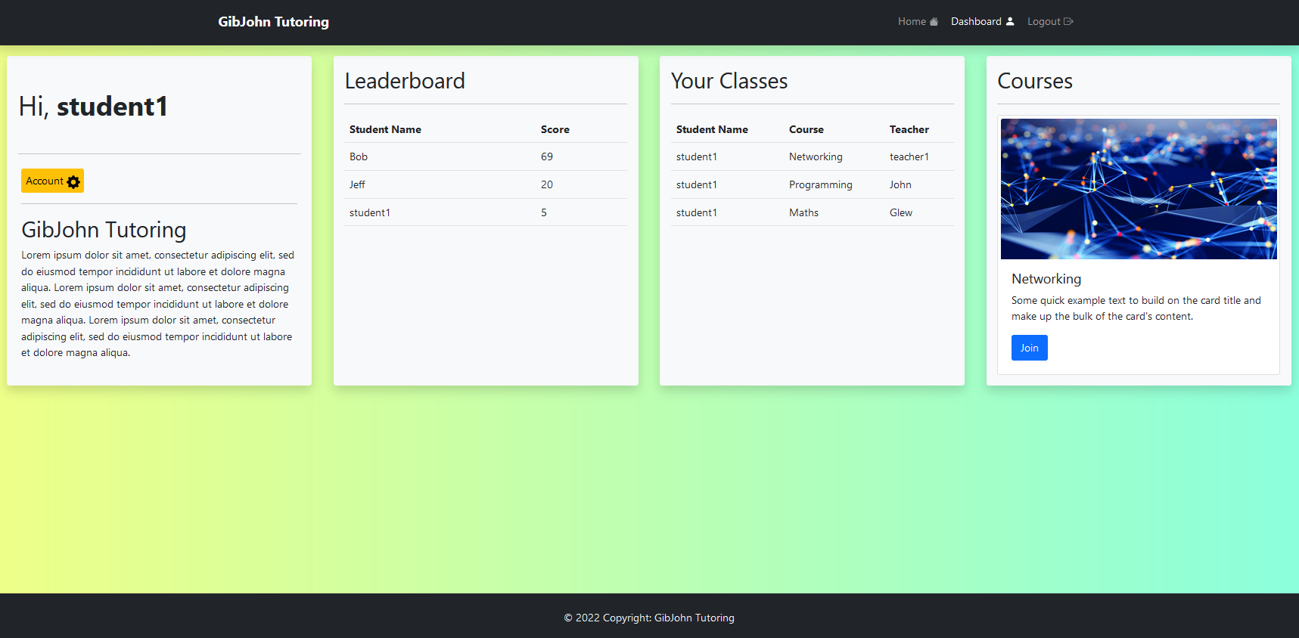

Added Icons and alt text

Students can now see their place on the leader board

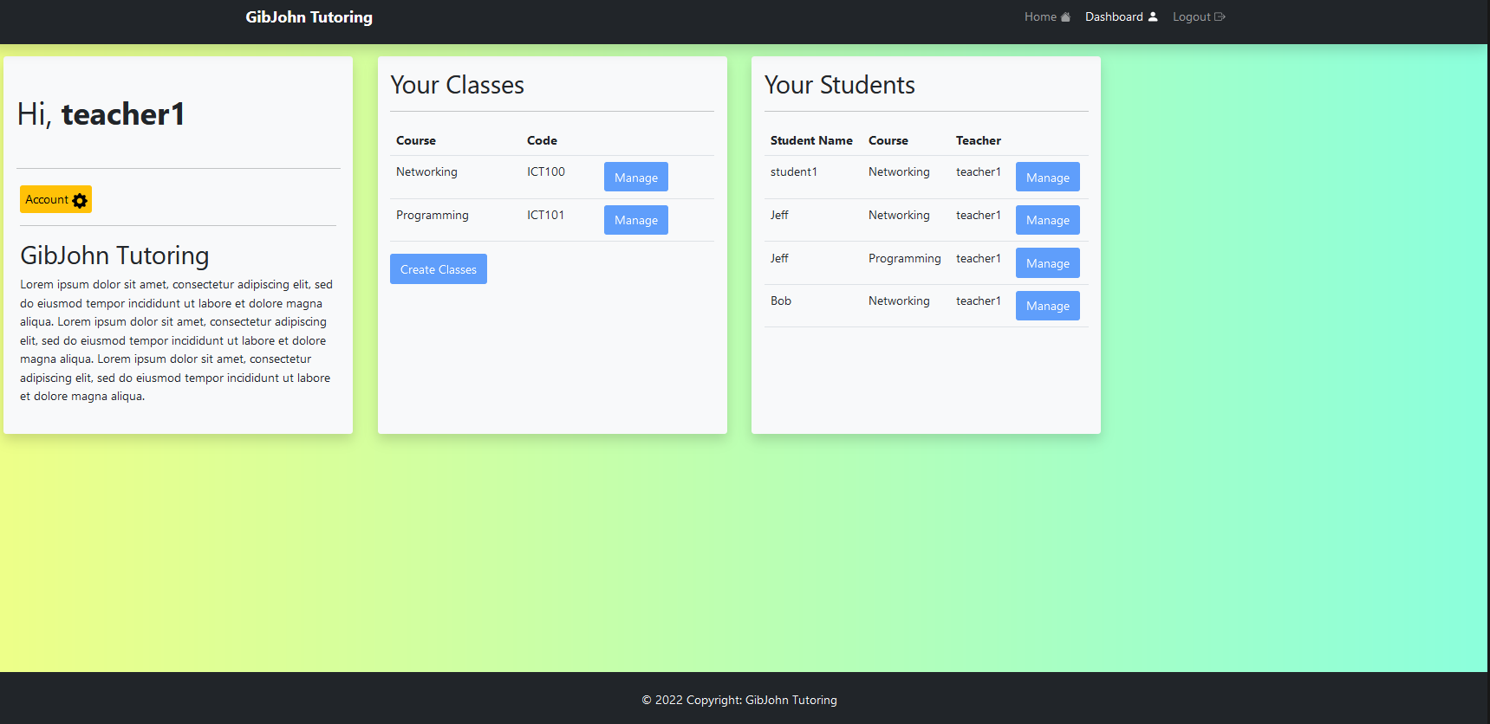

Teachers can see their students and their classes. The option to manage students, and classes will be a feature in the next version of the solution due to time constraints.

**Task 2: Developing the system prototype**

Asset Log:

|  |  |  |
| --- | --- | --- |
| Name | Purpose | Justification |
| Bootstrap | Bootstrap is a CSS framework that is recognised and used globally | Bootstrap is an open-source framework, it is the building blocks for the front end of the website. It has allowed the website to have a responsive, good-looking design that is modern and easy to use. |
| BladeOne Templating Engine | Blade is a templating engine that is seen in Laravel. BladeOne is a standalone version of blade. | Using Blade we are able to reuse code wherever necessary. Blade allows better organisation of code. Using blade you can separate all code, into a Model, View and controller framework. |
| Bootstrap Icons | Icons are used for accessibility purposes. | Bootstrap offers opensource icons that can be used by anyone. |

BladeOne: During development I didn’t separate CSS, HTML, Javascript and PHP as is intended when using Blade. I used Blade’s views and templates but I didn’t separate the code. This would be something to change in the next version of the website.

Both Bootstrap and BladeOne are open source, therefore no legal or ethical implications come into play when using them.

GibJohn tutoring is an educational tutoring company that provides their customers with:

* Face-to-face tutoring sessions
* Access to learning resources
* Support to develop understanding in different subjects

GibJohn tutoring has asked me to develop a prototype digital solution, to better help and support their customers. They want a digital solution that will:

* Provide interactive teaching and learning resources in a range of subjects
* Provide access to digital content to encourage wider learning
* Support assessment and monitoring of learner progress

Potential features include:

* Collaborative teaching and learning tools
* Accessibility features to support a wide range of users
* A learning reward system
* Gamified learning

My prototype will lay the foundation for a solution that has the potential to grow and expand to meet all of GibJohn Tutoring’s needs.

**The Home Page:**

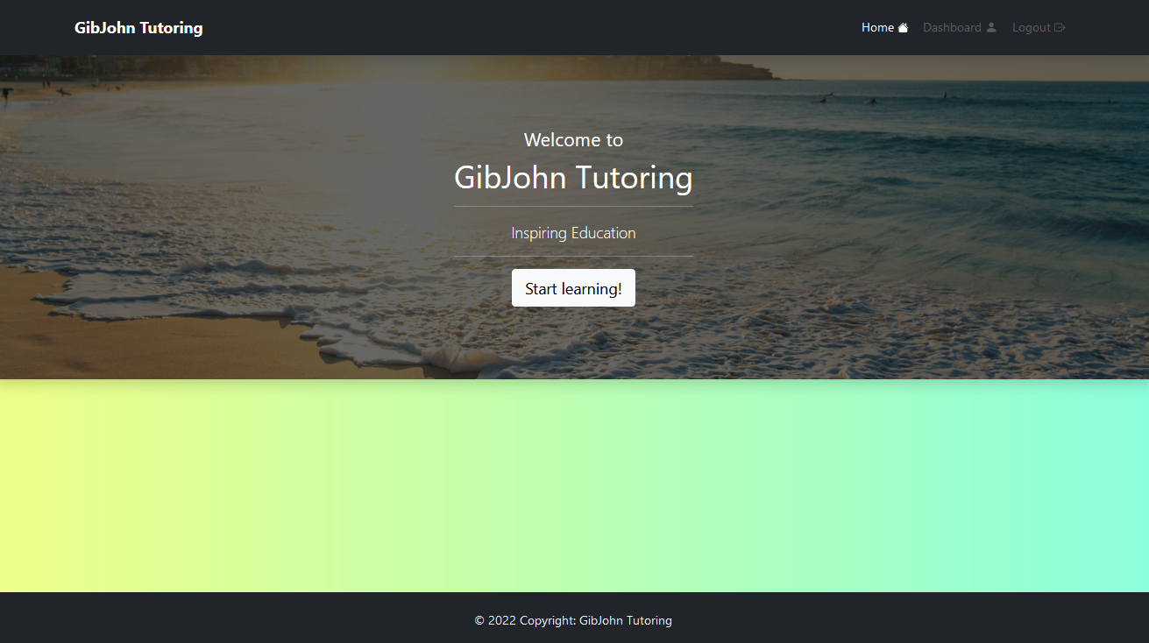

Using bootstrap, I took a minimalistic approach. For the prototype I didn’t fill the homepage with information. However, in the next version accurate data and user reviews, or an about us paragraph would fill the empty space and potentially make the website more attractive to customers visiting GibJohn tutoring’s website for the first time.

The Navigation bar will change depending on the page the user in on, however when a user is unable to access a page, it will be greyed out and the user won’t be able to interact with it. The website was designed with a minimalistic approach,

The Footer has copyright marker, letting the user know that all material on this website isn’t to be reused or copied without permission. Alt Text is used on all images to help with readers and accessibility.

Other accessibility features include Icons. Icons are often recognisable by the user. Most are universal. Icons can be understood by all users regardless of impairments or disabilities.

How it works:

This PHP script calls the view

Extends the view to the template

Starts or resumes a session, sessions are a way to store data across pages. Unlike cookies they’re not stored on the user’s device.

Blade’s Sections are like variables. Data can be stored in them and then called again somewhere else. In this case, a section called ‘gibjohndesc’ is being defined and called again in the template, which Is then shown on the browser.

I used Blade’s templates because layouts and templates can be used again and again. For example: on GibJohn’s website the footer and navigation bar are the same code called on different pages. This is because a page can share a layout with another page, and all layouts share the same navigation bar and footer. Any changes made to “Header.php” would take immediate effect on all pages. Websites not using Blade or similar PHP templating engine would need to change it for every page that uses it manually. Using layouts makes development easier and quicker because Blade allows the separation and reuse of code.

Code for the homepage template:

The head is used on all templates across the website. It gives the website its title, and links it too Bootstrap and its stylesheet.

The navigation bar is also used in all templates across the website. The navigation bar is consistent across each page, and allows the user to navigate easily through the website.

The Navigation bar uses classes to represent to the user what page they’re viewing. Each time a page is called, a variable called “page” is set to the name of the page that is being called. In this case it’s “home” for the homepage. The navigation bar checks this variable everytime the page is refreshed by using Blade’s own syntax @if statements. If the variable is equal to “home” the class “active” is assigned. This gives the appearance that the Home button is lit up when on the home page.



Dashboard and logout are disabled, using classes and if statements. This is because the user isn’t logged in and can’t view these pages until they do so.

**Teacher & Student Login/Signup selection page:**

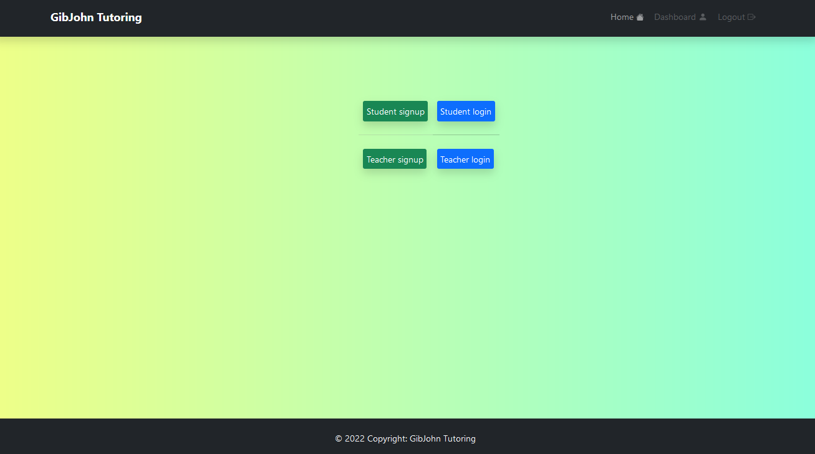

Using JavaScript, creating a singular page for login and signup for both user groups would make it easier to navigate and increase simplicity. However, for the prototype the user is redirected to the page they chose via a button.

Each input box uses data validation techniques that not only makes it easier for customers to enter the correct information, while giving feedback on errors but also protects against certain attacks that can be used to view or manipulate sensitive data in a database.

Students also have a very similar student signup page.

When a student or teacher signs up, It uses PHP’s Password_Hash() method. This encrypts the password when stored in the mySQL database making it much more secure and less vulnerable to attack.

Config.php

This allows the website to connect to the mySQL database.

Teachers table:

The user’s password gets hashed when stored in the database

When a student or teacher signs up to the website their data is stored here.

Students table:

Signup script:

Data validation, makes sure the user is using the correct information and isn’t trying to run SQL injection.

Gives feedback and lets the user know if they’ve made an error.

Redirects the user if they’re already logged in

This shows the signup script for teachers table, however students use the same script on a separate page that links to the student table.

Student signup, Teacher signup, student login and teacher login all use the same template. Which gives them a consistent look throughout.

Once the user has signed up, they’re redirected to the login page.

Hashing password

SQL statement inserts the username and hashed password into the database.

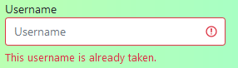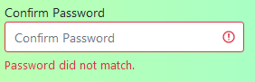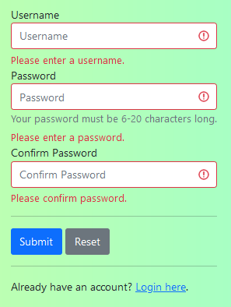

Reset is a shortcut that clears all the data in the form.

Different error messages occur depending on the type of error.

Clear error messages are passed to the user. Input boxes with the error turn red and shows an error icon. This is to make it as easy as possible for users to see the mistake.

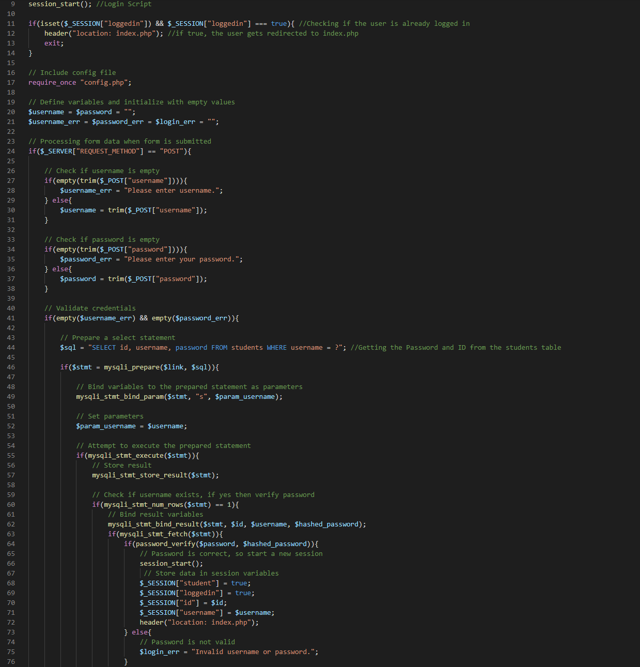

The Login script is similar to the Signup script, except instead of inserting new data, it checks data from the user against existing users in the database.

**Student and Teacher Dashboards:**

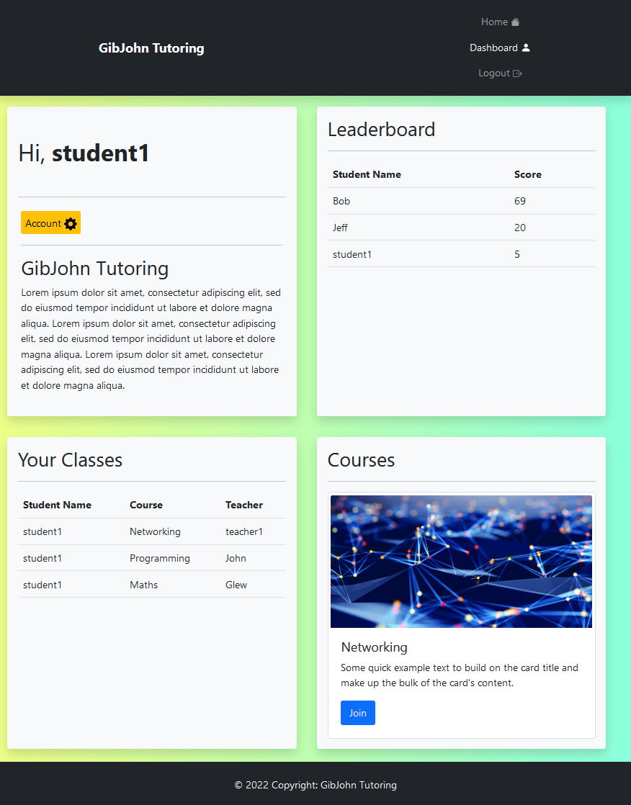

This is the student dashboard, On the dashboards students can see their classes, courses and leaderboard.

Each user has an ID. Using relational databases the tables display all relevant data to that user. A student can see only their teachers, course and classes.

The leaderboard provides students with a goal. As they complete tasks and course work they gain points which scores them a higher spot on the leaderboard.

All pages on the website are scalable to most size screens. This to make sure the website is accessible to as many different systems, screens, and users as possible.

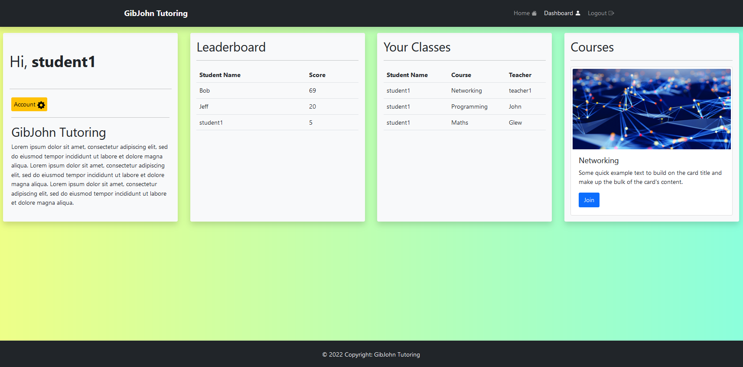

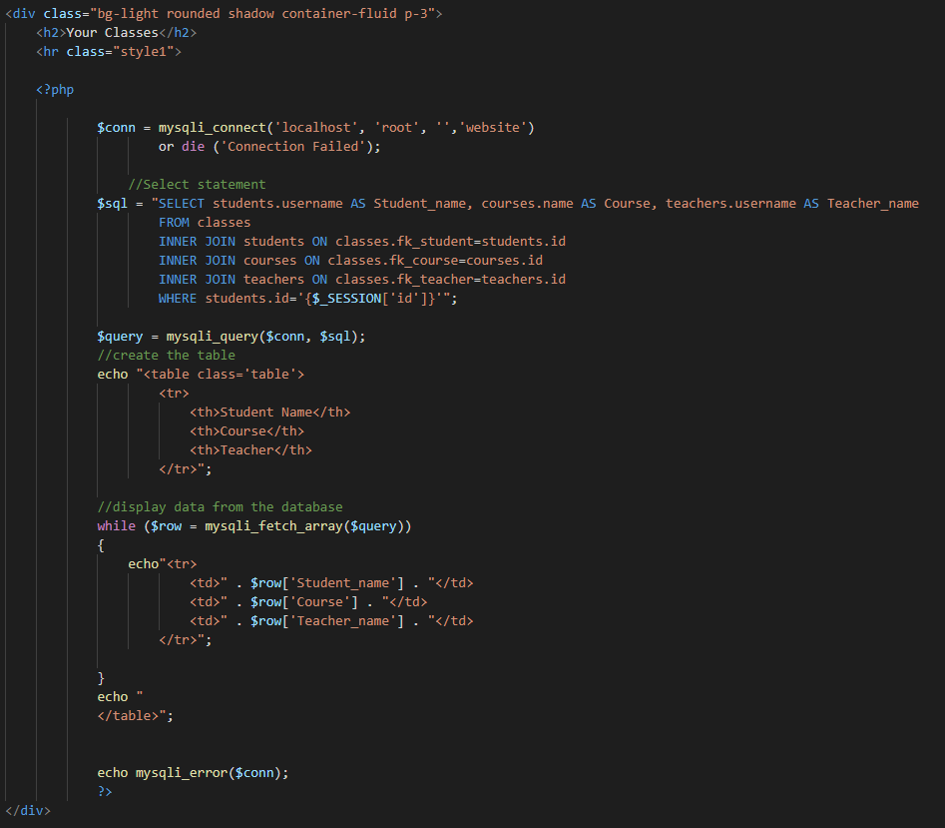

**Password Reset:**

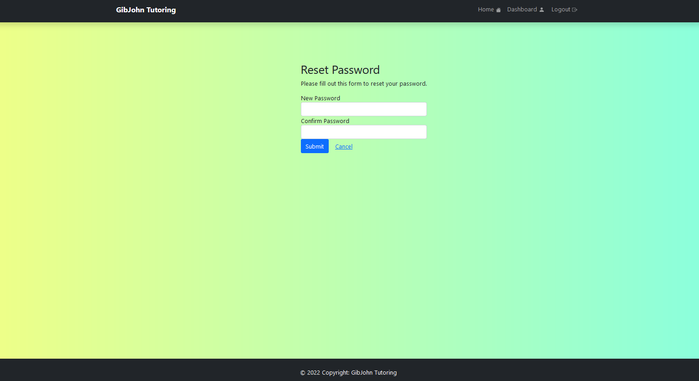

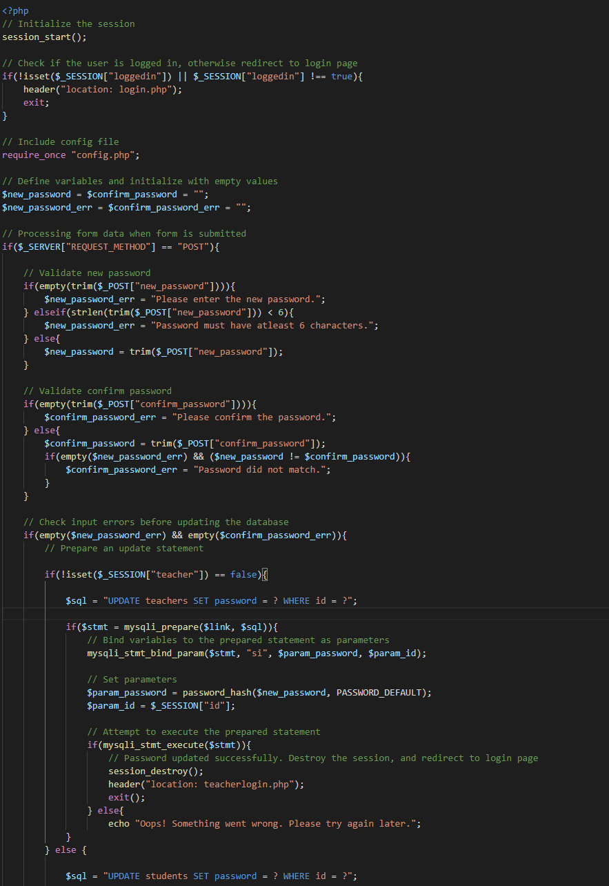

**Task 2: Test log**

|  |  |  |  |  |
| --- | --- | --- | --- | --- |
| **Description of test** | **Test data to be used (if required)** | **Expected outcome** | **Actual outcome** | **Comments and intended actions** |
| Signup to website | Teacher1  123456 | The user can use their details to sign up | The user can successfully sign up | Successful |
| Login to website | Teacher1  123456 | The user can log into their account and access their dashboard | The user can log into their account and access their dashboard | Successful |
| Test error messages when using the wrong details on signup | Teacher1  123  321 | Messages are displayed “Username isalready taken”  “Password must atleast be 6 characters long”  “Passwords don’t match” | All 3 error messages display as expected | Successful |
| Test error messages when no inputting anything on signup |  | Messages are displayed “Please enter a username”  “Please enter a password”  “Please confirm password” | All 3 error messages display as expected | Successful |
| Test login error messages | Teach1  123465 | Doesn’t login, error message “Invalid username or password” | User is unable to login and the error is displayed clearly | Successful |
| Password Hashing | Teacher1  Password2022 | The password is encrypted upon being stored in the database | The password is encrypted upon being stored in the database | Successful |
| Security | SQL Injection  " or ""="  105; DROP TABLE Teachers | Data validation rejects the syntax, making it less vulnerable to SQL injection | The query can’t be run on any of the input boxes | Security needs improvement, however it works against basic attacks |
| Navigation Bar |  | The navigation bar should show the page the current user is on, and if a page isn’t available it should be greyed out and unclickable | When the user visits the homepage the “Home” button is highlighted. After logging out the Dashboard and Logout buttons become greyed out as they are now unavailable to the user. | Successful |
| Dashboard: A teacher can see their students and classes taught |  | The dashboard shows all current students and classes accurately, based of the relational database  A teacher can’t see students they don’t teach | The teacher can see each class they teach. They can see the subject and the code for the course.  The teacher is only able to see their students. | Successful |
| Dashboard: A student can see their courses, leader board and their classes |  | A student is able to see a leader board, which shows in order the students with the highest points, they can see their classes which includes the teacher which teaches that course and the name of the course. | The student is able to view the each table successfully. The student can only view their data and no one elses. | Successful |
| Logout script |  | A user that is logged in can click the logout button at any time, it will return them to the homepage and they won’t be able to access their dashboard anymore. | The user can logout of their account. They are unable to access their dashboard and their data. | Successful |
| Reset password | Reset2022 | A user can reset their password from the dashboard. They input their new password, and then re-enter to confirm. Once completed they are made to sign in again | The user can use a new password for their account. And upon resetting their password it is updated in the database immediately and they have to log back into their account. | Successful |
| Scalability |  | A user is able to resize their browser window and the website adjusts to the new screen size properly. | When the window is resized the website successfully adjusts most of the time. | Scalability needs improving. Occasionally objects re-arrange in the wrong order and it doesn’t look visually appealing. |